# Class23. SharePoint Branding

**Publishing site =>stting**

|  |  |
| --- | --- |
| |  | | --- | | Look and Feel  * [Design Manager](https://nmek.sharepoint.com/sites/2019Publish/_layouts/15/RedirectPage.aspx?Target=%7bSiteCollectionUrl%7d%7bLayoutsFolder%7dDesignSite.aspx) * [Master page](https://nmek.sharepoint.com/sites/2019Publish/_layouts/15/ChangeSiteMasterPage.aspx)=> uses to keep some part to across all the part of the page. * [Title, description, and logo](https://nmek.sharepoint.com/sites/2019Publish/_layouts/15/prjsetng.aspx) * [Welcome Page](https://nmek.sharepoint.com/sites/2019Publish/_layouts/15/AreaWelcomePage.aspx) => is the first page * [Page layouts and site templates](https://nmek.sharepoint.com/sites/2019Publish/_layouts/15/AreaTemplateSettings.aspx) => to create subsite & publishing pages, uses to keep some part to some parts of the page. * [Navigation Elements](https://nmek.sharepoint.com/sites/2019Publish/_layouts/15/navoptions.aspx) * [Change the look](https://nmek.sharepoint.com/sites/2019Publish/_layouts/15/designgallery.aspx) * [Import Design Package](https://nmek.sharepoint.com/sites/2019Publish/_layouts/15/DesignPackageInstall.aspx) * [Navigation](https://nmek.sharepoint.com/sites/2019Publish/_layouts/15/AreaNavigationSettings.aspx) * [Image Renditions](https://nmek.sharepoint.com/sites/2019Publish/_layouts/15/ImageRenditionSettings.aspx) => to configure the same image in different sizes  Web Designer Galleries  * [Site columns](https://nmek.sharepoint.com/sites/2019Publish/_layouts/15/mngfield.aspx) * [Site content types](https://nmek.sharepoint.com/sites/2019Publish/_layouts/15/mngctype.aspx) * [Web parts](https://nmek.sharepoint.com/sites/2019Publish/_catalogs/wp/Forms/AllItems.aspx) * [List templates](https://nmek.sharepoint.com/sites/2019Publish/_catalogs/lt/Forms/AllItems.aspx) * [Master pages and page layouts](https://nmek.sharepoint.com/sites/2019Publish/_layouts/15/RedirectPage.aspx?Target=%7bSiteCollectionUrl%7d_catalogs/masterpage) => is the most important which used to design artifacts, we uploaded here * [Themes](https://nmek.sharepoint.com/sites/2019Publish/_catalogs/theme/Forms/AllItems.aspx) * [Solutions](https://nmek.sharepoint.com/sites/2019Publish/_catalogs/solutions/Forms/AllItems.aspx) * [Composed looks](https://nmek.sharepoint.com/sites/2019Publish/_catalogs/design/AllItems.aspx) | |

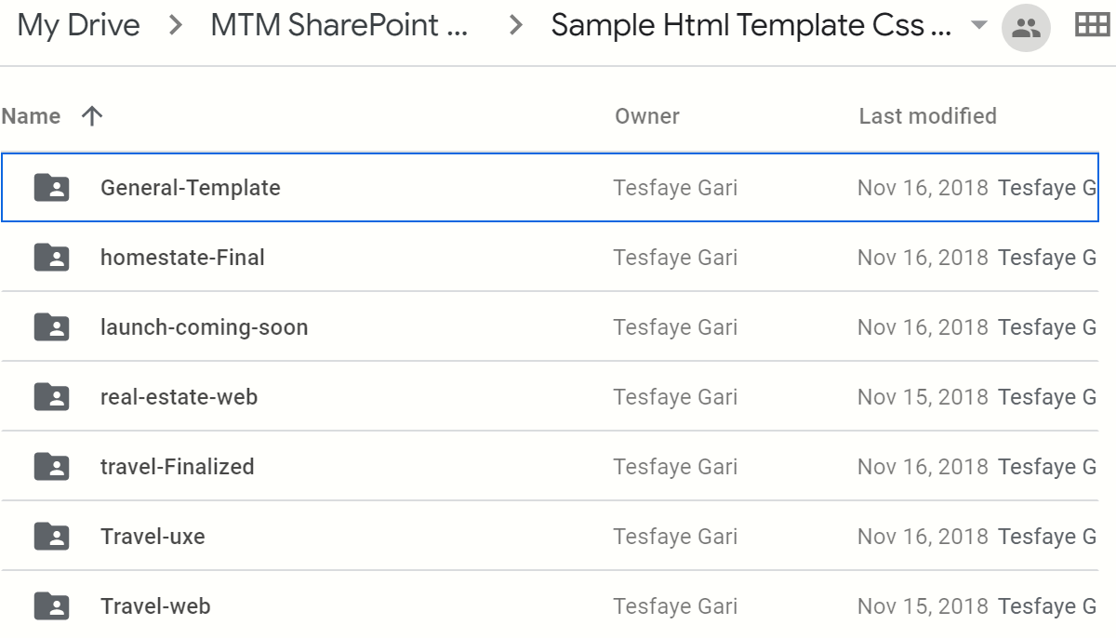

**Favicon**=>is an icon of website (eg icon of yutoub )

* Changes:

[Url:(any link)](Url:(any%20link)) to # =>b/se we don’t need break when we take it to sharepoint page

Form to div

Row areas to <h></h> and the adjest the padding

* Delete: hero area

Popular area

Search area

Then we get stiky navigation mean the navigation area can’t move the only the content area is mone. So we need CSS.

**Working publishing on site**

**Design Manager**

1. [Welcome](https://nmek.sharepoint.com/sites/2019Publish/_layouts/15/DesignWelcomePage.aspx)=>introduction part
2. [Manage Device Channels](https://nmek.sharepoint.com/sites/2019Publish/_layouts/15/DesignChannels.aspx)=>don’t touch this
3. [Upload Design Files](https://nmek.sharepoint.com/sites/2019Publish/_layouts/15/DesignMapDrive.aspx)
4. [Edit Master Pages](https://nmek.sharepoint.com/sites/2019Publish/_layouts/15/DesignMasterPages.aspx)
5. [Edit Display Templates](https://nmek.sharepoint.com/sites/2019Publish/_layouts/15/DesignDisplayTemplates.aspx)
6. [Edit Page Layouts](https://nmek.sharepoint.com/sites/2019Publish/_layouts/15/DesignPageLayouts.aspx)
7. [Publish and Apply Design](https://nmek.sharepoint.com/sites/2019Publish/_layouts/15/DesignAssignMaster.aspx)
8. [Create Design Package](https://nmek.sharepoint.com/sites/2019Publish/_layouts/15/DesignPackageExport.aspx)

**3.[Upload Design Files](https://nmek.sharepoint.com/sites/2019Publish/_layouts/15/DesignMapDrive.aspx" \o "Map the Master Page Gallery as a network drive on your computer)**

Site setting =>Design manager=>[Upload Design Files](https://nmek.sharepoint.com/sites/2019Publish/_layouts/15/DesignMapDrive.aspx)

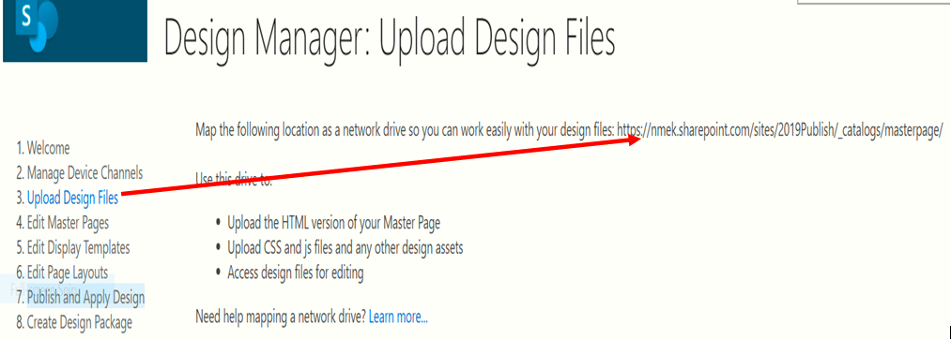

<https://nmek.sharepoint.com/sites/2019Publish/_catalogs/masterpage/> => it is not a link on chrome but it is a link on IE b/se Internet Explorer has some special features on Microsoft b/se it buil by Microsoft

To check it copy the top link(<https://nmek.sharepoint.com/sites/2019Publish/_layouts/15/DesignMapDrive.aspx>) from the chrome and paste at IE then we get the following link.

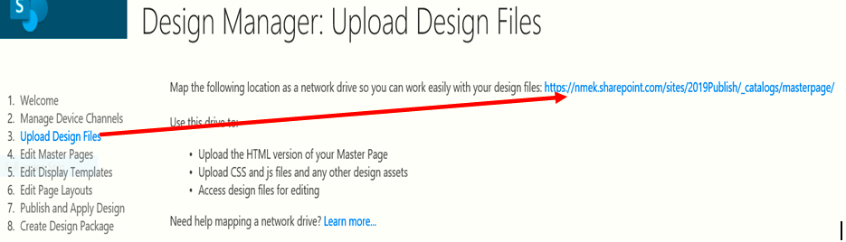

You see, it is the link at IE.

The link opens window explorer: To open WEXP.

* 1. Simply by click on it or
  2. Copy the link and open it the new tab => Library=>**open with explorer** or
  3. Site setting => [Master pages and page layouts](https://nmek.sharepoint.com/sites/2019Publish/_layouts/15/RedirectPage.aspx?Target=%7bSiteCollectionUrl%7d_catalogs/masterpage)=> Library=> **open with explorer**

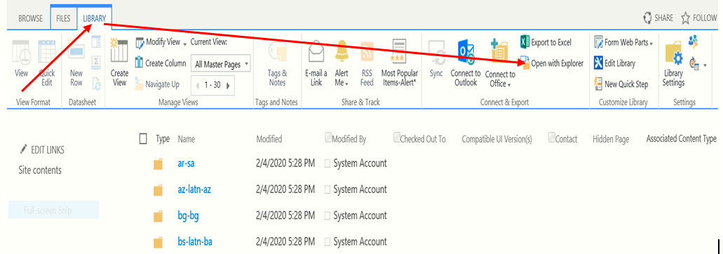

Then we get

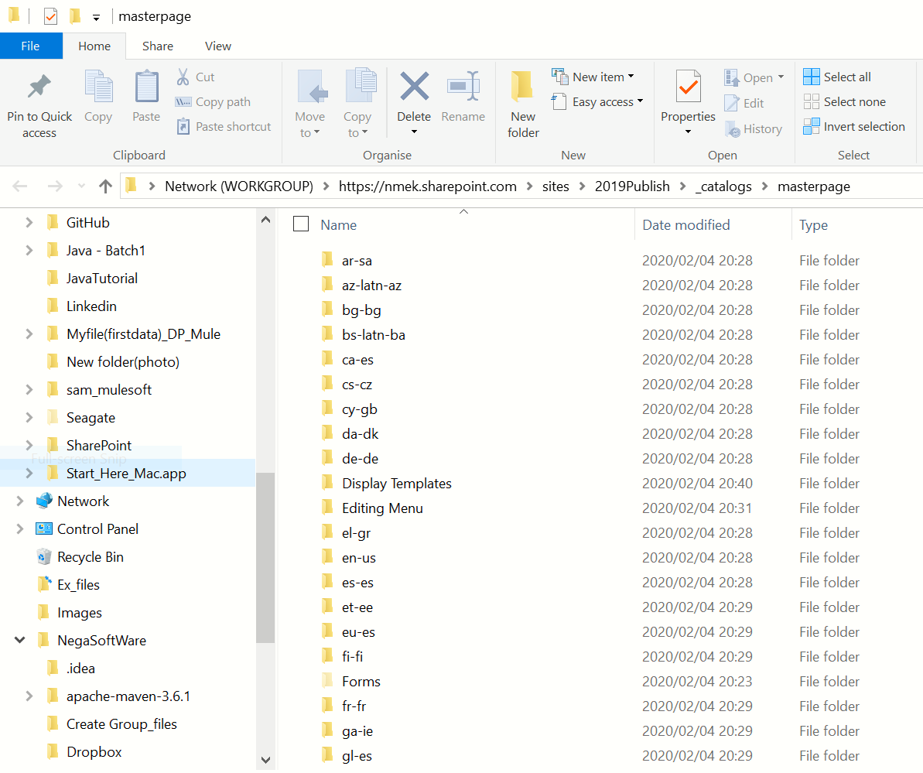

Then we should upload our file to this window explorer.

* 1. [**Edit Master Pages**](https://nmek.sharepoint.com/sites/2019Publish/_layouts/15/DesignMasterPages.aspx)

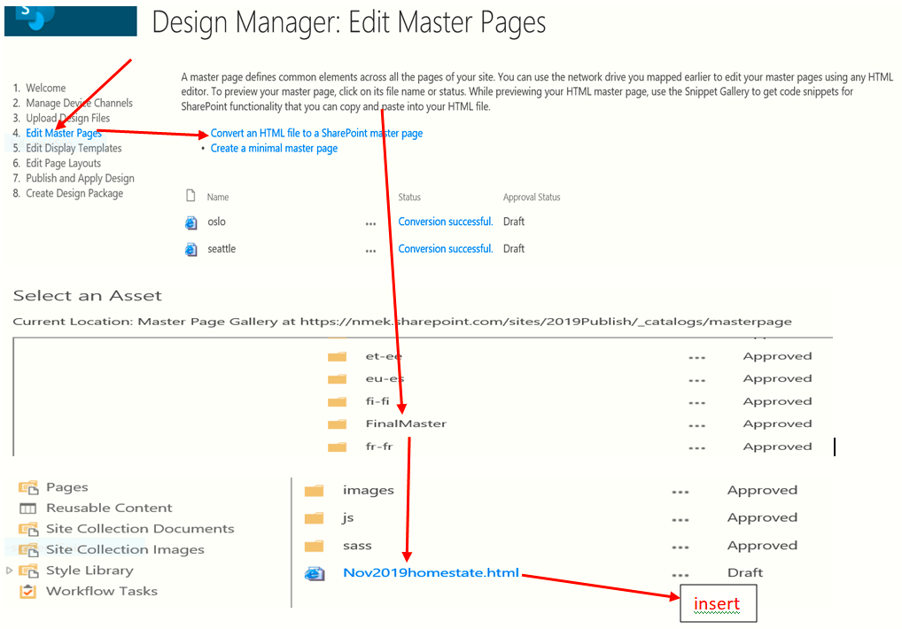

**Then we get**

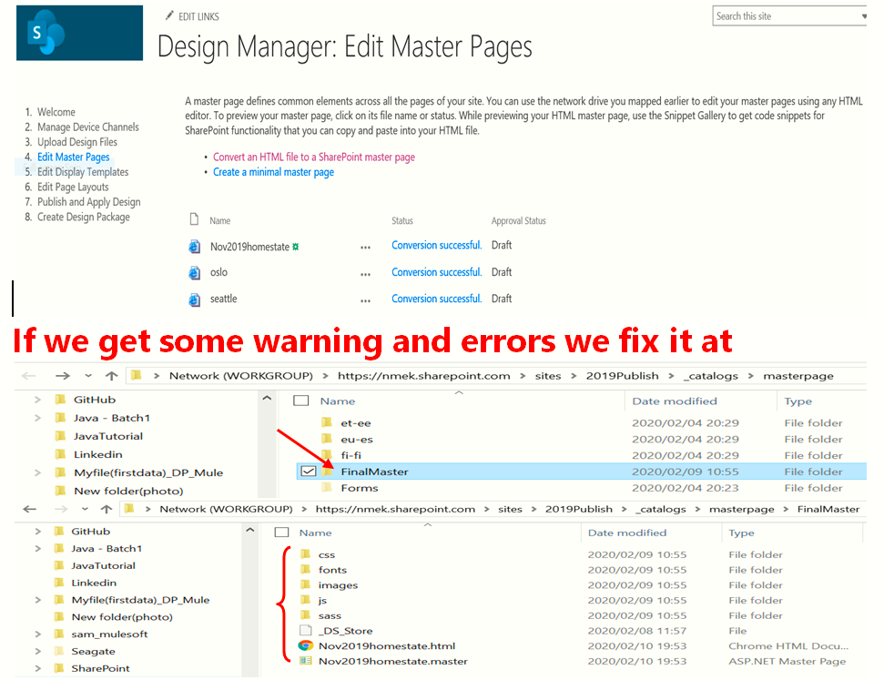

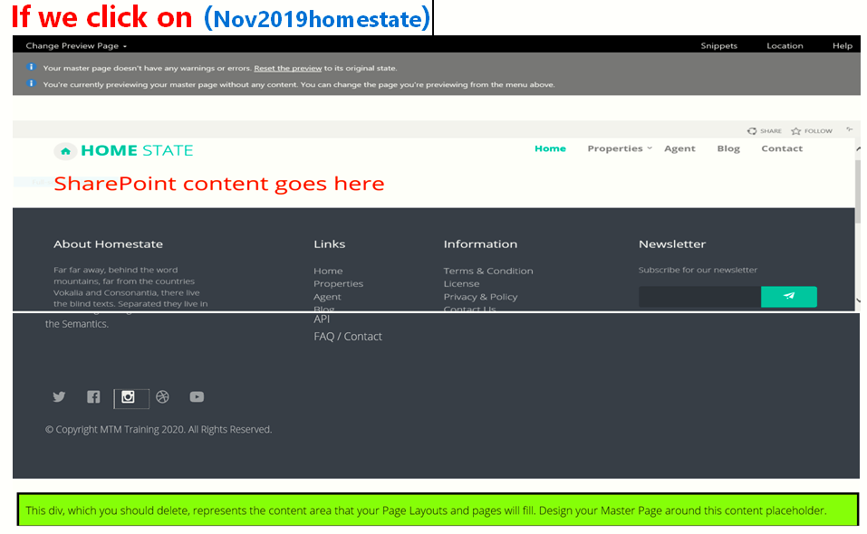

**This is our expectation!**

**sinppets: click it and look the result that is very important.**

**How can we put the main master page next to Logo/at page contentment.**

**We don’t need our local we use our sharepoint Explorer.**

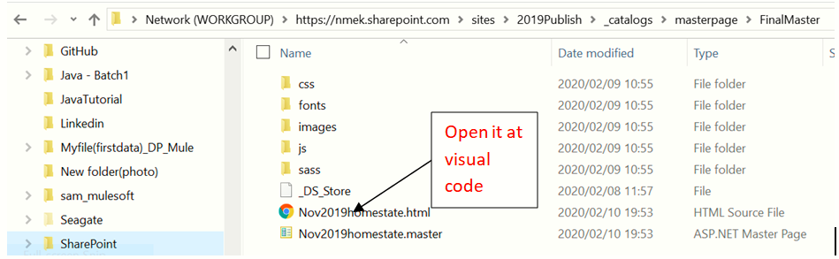

Change in visual studio:

* Collapse and keep the header section b/se it use to fix the navigation part and Logo later on
* Collapse the footer
* <div data-name="ContentPlaceHolderMain"> 🡺 the yellow Area

This is the new thing which is created by default.div instead of h1/ by deleting h1.

Collapse and cut it and then paste between

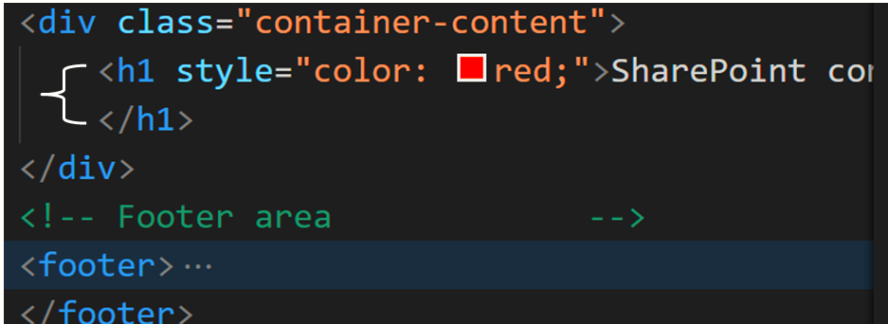

Then we get

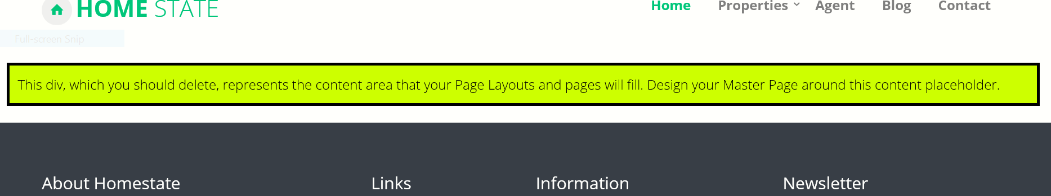

Go back to the master page by cutting the part of top link after publish/ that mean:

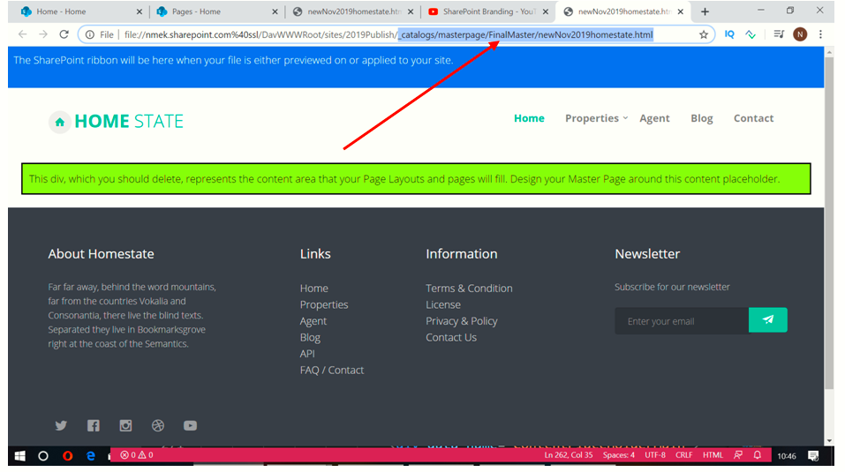

[Publish and Apply Design](https://nmek.sharepoint.com/sites/2019Publish/_layouts/15/DesignAssignMaster.aspx)

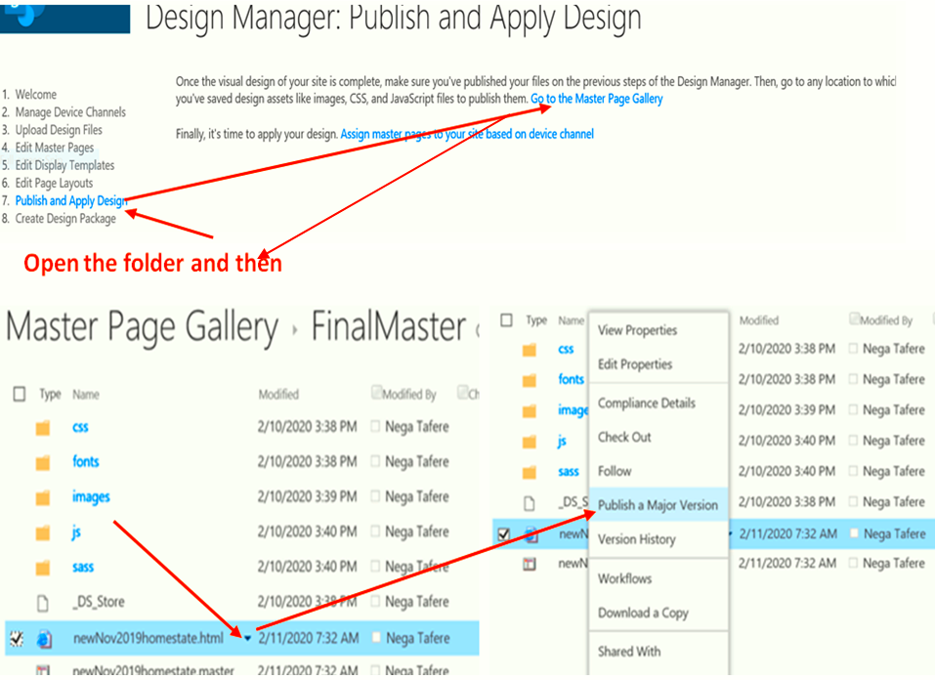

[**Publish and Apply Design**](https://nmek.sharepoint.com/sites/2019Publish/_layouts/15/DesignAssignMaster.aspx)**=>** [**Assign master pages to your site based on device channel**](https://nmek.sharepoint.com/sites/2019Publish/_layouts/15/ChangeSiteMasterPage.aspx)

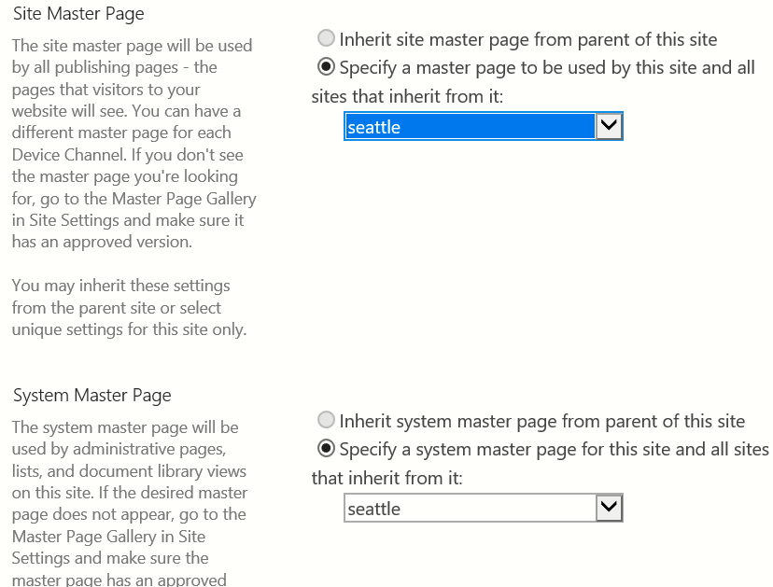

**SharePoint uses two master pages**

* Site/Actual/user master page
* System master page=>contains settings and view/list view
* Let we set the Site master page by

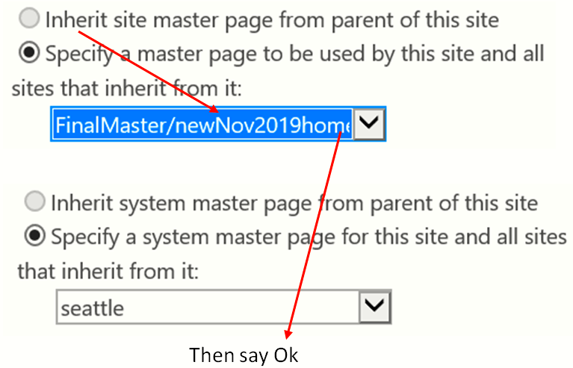

And then go to the Master page (<https://nmek.sharepoint.com/sites/2019Publish/>) we get

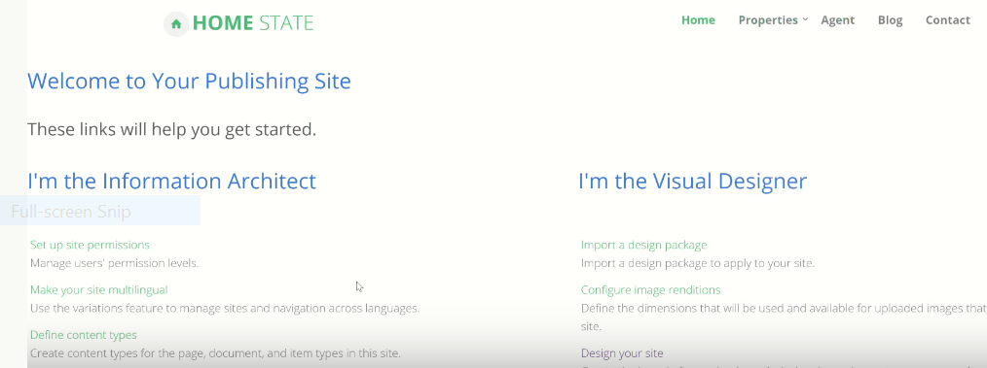

Nice page

**Edit the page**

* **buttons are overlapped:**

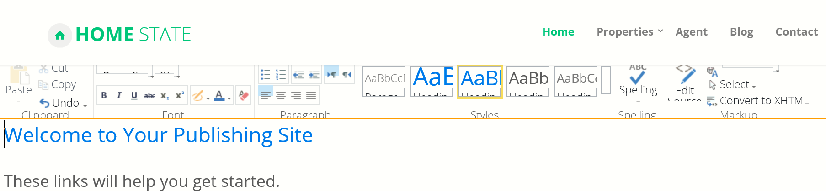

It needs some modifications b/se some buttons are overlapped

That is CSS.

* **Icon changed b/se of Bootstrap**

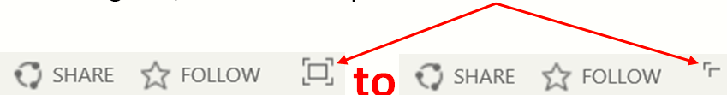

* **The bottom padding needs some change**

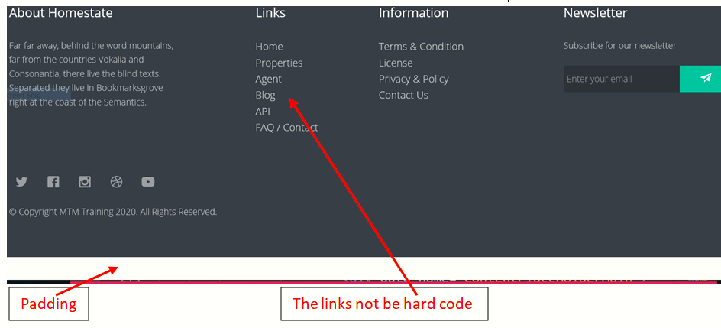

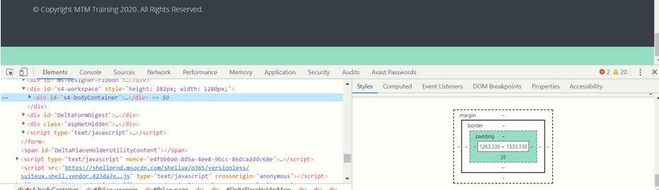

or

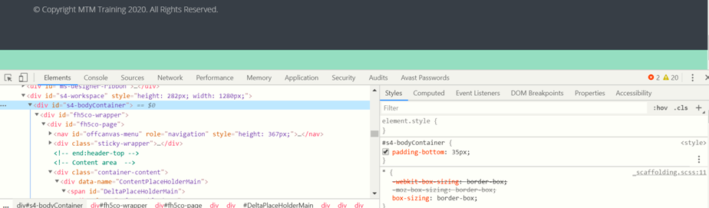

Make an checked: padding-bottom: 35px;to remove the padding.

End of class 23

================///==================